“FIRE NOC APPLICATION PORTAL”
A Project Report Submitted in the partial fulfillment of the requirements for the award of the degree of

BACHELOR OF TECHNOLOGY
In

DEPARTMENT OF ELECTRONICS & COMMUNICATION ENGINNERING

By

T. Sharon Rhoda 2520040001
J. Krishna Chaithanya 2520040049

Under the Esteemed Guidance of

K. Anusha
Assistant Professor
Department of Computer Science and Engineering




K L (Deemed to be) University DEPARTMENT OF ELECTRONICS & COMMUNICATION ENGINEERING



Declaration

The Project Report entitled “FIRE NOC APPLICATION PORTAL” is a record of Bonafide work of T. Sharon Rhoda - 2520040001, J. Krishna Chaithanya - 2520040049, submitted in partial fulfillment for the award of B. Tech in Computer Science and Engineering (or) Computer Science and Information Technology to the K L University. The results embodied in this report have not been copied from any other departments/University/Institute.

T. SHARON RHODA – 2520040001

J. KRISHNA CHAITHANYA - 2520040049
K L (Deemed to be) University

DEPARTMENT OF ELECTRONICS AND COMMUNICATION ENGINEERING



CERTIFICATE

This is certify that the mini project based report entitled “FIRE NOC APPLICATION PORTAL” is a bonafide work done and submitted by T. SHARON RHODA - 2520040001, J. KRISHNA CHAITHANYA - 2520040049, in partial fulfillment of the requirements for the award of the degree of BACHELOR OF TECHNOLOGY in Department of Computer Science Engineering, K L (Deemed to be University), during the academic year 2025-2026.

Signature of the Guide

Signature of the Course Coordinator Signature of the HOD

ACKNOWLEDGEMENT
The success in this project would not have been possible but for the timely help and guidance rendered by many people. Our wish to express my sincere thanks to all those who has assisted us in one way or the other for the completion of my project.

Our greatest appreciation to my Course Coordinator Dr. K. Madhavi and my guide K. Anusha, Department of Computer Science which cannot be expressed in words for his/her tremendous support, encouragement and guidance for this project.

We express our gratitude to Dr. Sunkara Srinivas(ECE), Head of the Department for Electronics and Communication Engineering for providing us with adequate facilities, ways and means by which we are able to complete this project-based Lab.

We thank all the members of teaching and non-teaching staff members, and also who have assisted me directly or indirectly for successful completion of this project. Finally, I sincerely thank my parents, friends and classmates for their kind help and cooperation during my work.

T. SHARON RHODA – 252004001

J. KRISHNA CHAITHANYA - 2520040049

Abstract

The Fire NOC (No Objection Certificate) Application Portal is a web-based e-Governance solution developed to simplify and digitize the process of obtaining Fire Safety No Objection Certificates for commercial, industrial, institutional, and residential buildings. Traditionally, the Fire NOC application process involves extensive paperwork, multiple office visits, manual verification, and delayed approvals. These challenges often result in inconvenience for applicants and increased administrative workload for fire department officials.

The proposed Fire NOC Application Portal provides a centralized online platform where applicants can register, submit Fire NOC applications, upload required documents such as building plans and fire safety layouts, schedule inspections, track application status, and download digitally approved certificates. The portal also enables fire department officials to review applications, verify submitted documents, conduct inspections, record observations, approve or reject applications, and manage certificates efficiently.

The system is developed using HTML5, CSS3, JavaScript (ES6+), React.js, Node.js, Express.js, and MySQL. React.js provides a responsive and interactive user interface, while Node.js and Express.js handle server-side operations and API services. MySQL securely stores applicant details, application records, inspection reports, and certificate information. REST APIs facilitate communication between the frontend and backend, ensuring smooth and reliable data exchange.

The portal incorporates secure user authentication, role-based access control, encrypted passwords, online document management, inspection scheduling, notification services, and certificate generation. Applicants receive real-time updates through email or SMS notifications regarding application progress and inspection schedules. The digital workflow significantly reduces paperwork, minimizes processing time, enhances transparency, and improves communication between applicants and the Fire Department.

The Fire NOC Application Portal supports the Digital India initiative by promoting paperless governance, faster public service delivery, and improved administrative efficiency. The modular architecture allows future integration with GIS mapping, Aadhaar authentication, online payment gateways, and AI-based fire risk assessment systems.
Overall, the proposed system offers a reliable, secure, scalable, and user-friendly solution for automating Fire NOC services while ensuring regulatory compliance and enhancing citizen satisfaction.

Index

S.  No. | Chapters | Topics | Page.no
 |  | Acknowledgement
 |  | Abstract
1 | Introduction | - Background of the project  - Problem statement  - Scope of the project  - Objective(s)  - Importance of the application  - Target users/audience | 5-15
2 | System Requirements | - Hardware requirements  - Software requirements  - Development tools and frameworks | 16-21
3 | Technology Stack | - Front-end (e.g., React.js, Angular, HTML/CSS)  - Back-end (e.g., Node.js, Django, Spring Boot)  - Database (e.g., MongoDB, MySQL, PostgreSQL)  - Version Control (e.g., Git, GitHub)  - APIs or External services (e.g., Firebase, Stripe) | 22-32
4 | System Architecture | - High-level architecture diagram  - Description of each layer (frontend, backend, database)  - Deployment architecture (e.g., cloud, local, CI/CD  pipelines) | 33-36
5 | Design | 5.2 ER Diagram / Database schema | 37
6 | Implementation | - Module-wise implementation  - Front-end logic (UI rendering, state management)  - API integration  - Authentication & Authorization | 38-47
7 | Features | - List of main features  - How each feature works (user perspective + technical description) | 48-55
8 | Testing | - Postman testing (frontend/backend)  - Integration testing  - Tools used for testing  - Test cases and results | 56-64
9 | Deployment | - Steps to deploy  - Environment configuration  - Hosting of frontend and backend | 65-73
10 | Challenges & Limitations | - Issues faced during development  - Solutions applied  - Current limitations or known bugs | 74-82
11 | Future Enhancements | - Planned features  - Possible integrations or optimizations | 83-88
12 | Conclusion | - Summary of the project  - What was achieved  - Skills learned during development | 89-97
13 | References | - Books, tutorials, APIs, documentation sites used | 98-99

14 | Appendices | - Screenshots of the app  - Sample code snippets  - Installation/setup instructions  - User manual or guide  -Geo Tag photos with guide  -Review forms with guide signatures | 100-105

CHAPTER -1 INTRODUCTION

Background of the Project

Fire safety plays a critical role in protecting human life, public property, and the environment. Government regulations require commercial establishments, educational institutions, hospitals, shopping malls, industrial buildings, and high-rise residential complexes to obtain a Fire No Objection Certificate (Fire NOC) before commencing operations. The certificate confirms that a building complies with prescribed fire safety standards and is equipped with adequate fire prevention and emergency response systems.

Traditionally, obtaining a Fire NOC involves submitting physical application forms, building plans, structural drawings, fire equipment details, and other supporting documents to the Fire Department. Applicants often need to visit government offices multiple times for document submission, status inquiries, inspection scheduling, and certificate collection. This manual process is time-consuming, labor-intensive, and susceptible to delays, errors, and lack of transparency.

The rapid advancement of Information Technology and Digital Governance has created opportunities to modernize government services through online platforms. Digital portals improve accessibility, streamline administrative workflows, reduce paperwork, and provide citizens with convenient access to public services. Recognizing these benefits, the Fire NOC Application Portal has been developed as an integrated web-based platform to automate the complete Fire NOC application lifecycle.

The portal enables applicants to create user accounts, submit online applications, upload required documents, schedule inspections, monitor application status, receive notifications, and download approved certificates electronically. At the same time, Fire Department officials can review applications, verify documents, schedule inspections, record inspection reports, approve or reject requests, and maintain digital records using a centralized administrative dashboard.

The system is developed using modern web technologies including React.js for the frontend, Node.js and Express.js for backend services, and MySQL as the relational database management system. The architecture follows a modular and scalable design, allowing easy maintenance, future enhancements, and integration with external government services.

The Fire NOC Application Portal aligns with the Government of India's Digital India initiative by promoting paperless governance, transparent public service delivery, and efficient administrative processes. It reduces manual intervention, shortens processing time, improves record management, and enhances communication between citizens and government authorities.

By automating the Fire NOC process, the proposed system contributes to improved fire safety compliance, better regulatory enforcement, enhanced public convenience, and increased operational efficiency within Fire and Emergency Services Departments.

Problem Statement

Fire safety is one of the most important aspects of public safety, especially in commercial buildings, industries, hospitals, educational institutions, shopping malls, hotels, warehouses, and high-rise residential complexes. Before these buildings become operational, they are required to obtain a Fire No Objection Certificate (Fire NOC) from the Fire Department, certifying that the premises comply with all prescribed fire safety regulations.
Despite the importance of Fire NOC certification, the existing application process in many government departments is largely manual and paper-based. Applicants are required to visit government offices multiple times to collect application forms, submit documents, schedule inspections, verify application status, and finally receive the approved certificate. This traditional system is inefficient, time-consuming, and lacks transparency.
The manual processing of Fire NOC applications creates several challenges for both applicants and government officials. Since all records are maintained physically, there is a high possibility of misplaced documents, duplicate records, human errors, and delays in processing. Applicants often remain unaware of the status of their applications because there is no online tracking mechanism. As a result, unnecessary visits to government offices increase both time and travel expenses.
Another major challenge is inspection scheduling. Fire officers manually coordinate inspections through phone calls or written notices, making the process slow and unorganized. If an inspection is postponed, applicants receive delayed information, further increasing the waiting period for certificate approval.
The absence of a centralized digital database also makes it difficult for government officials to retrieve historical application records, inspection reports, and certificate details. Maintaining physical files consumes storage space and increases administrative workload.
Security is another significant concern. Physical documents are more vulnerable to loss, unauthorized access, and damage. Without proper authentication mechanisms, verifying applicant identity and maintaining record confidentiality becomes difficult.
Furthermore, the lack of automated notifications results in poor communication between applicants and the Fire Department. Applicants are often unaware of missing documents, inspection schedules, approval decisions, or rejection reasons until they personally visit the department.
To overcome these limitations, there is a need for an integrated web-based Fire NOC Application Portal that automates the complete application lifecycle. The proposed system provides online registration, digital document upload, automated inspection scheduling, application tracking, certificate generation, and administrative management through a secure and user-friendly platform.
The proposed portal addresses the following problems:
- Eliminates manual paperwork.
- Reduces application processing time.
- Enables online document submission.
- Provides real-time application status tracking.
- Simplifies inspection scheduling.
- Enhances transparency.
- Improves communication through notifications.
- Maintains secure digital records.
- Supports paperless governance.
- Improves overall administrative efficiency.

Scope of the Project
The Fire NOC Application Portal is designed to digitize the complete Fire No Objection Certificate application process and provide an efficient online platform for applicants and Fire Department officials.
The primary scope of the project includes providing citizens with an online system where they can apply for Fire NOC certificates without visiting government offices. Applicants can register, log in securely, fill out application forms, upload building plans, fire safety layouts, ownership documents, and other required certificates.
The system allows applicants to schedule fire safety inspections based on available dates. Fire Department officials receive inspection requests, verify submitted documents, inspect buildings, submit inspection reports, and approve or reject applications using the administrative dashboard.
The portal provides real-time application tracking so applicants can monitor every stage of processing, including:
- Application Submitted
- Document Verification
- Inspection Scheduled
- Inspection Completed
- Under Review
- Approved
- Rejected
- Certificate Generated
The system generates digital Fire NOC certificates that applicants can download anytime after approval.
The administrative module enables Fire Department officials to:
- Manage applications.
- Verify uploaded documents.
- Schedule inspections.
- Assign inspectors.
- Record inspection observations.
- Approve or reject applications.
- Generate digital certificates.
- Maintain applicant records.
- Generate reports.
The project also includes secure login, role-based authentication, encrypted password storage, responsive web design, and database management.
The portal is designed to support future expansion such as:
- Online payment gateway
- GIS building mapping
- Aadhaar verification
- SMS notifications
- AI-based fire risk analysis
- Mobile application support
- Cloud deployment
- Digital signature integration
Thus, the project scope extends from application submission to certificate generation while ensuring transparency, efficiency, and regulatory compliance.

Objectives of the Project

The primary objective of the Fire NOC Application Portal is to develop a secure, efficient, and user-friendly web application that automates the Fire No Objection Certificate issuance process.

The specific objectives include:

Primary Objectives

Develop a fully digital Fire NOC application system.

Eliminate manual paperwork.

Reduce application processing time.

Improve transparency.

Provide secure online document submission.

Enable online inspection scheduling.

Generate digital Fire NOC certificates.

Improve communication between applicants and Fire Department officials.

Technical Objectives

Develop responsive web pages using React.js.

Build REST APIs using Node.js and Express.js.

Store application data securely using MySQL.

Implement role-based authentication.

Protect passwords using encryption.

Maintain secure database transactions.

Implement real-time application tracking.

Generate downloadable PDF certificates.

Administrative Objectives

Simplify document verification.

Automate inspection scheduling.

Maintain digital inspection reports.

Reduce administrative workload.

Improve departmental efficiency.

Generate analytical reports.

User Objectives

Easy online registration.

Simple application submission.

Upload supporting documents.

Track application status.

Receive notifications.

Download certificates online.

Overall, the project aims to modernize Fire Department services while promoting Digital India initiatives and e-Governance.

Importance of the Application

The Fire NOC Application Portal plays a significant role in improving public service delivery by digitizing an essential government approval process.

The application benefits citizens, businesses, industries, and government officials alike.

Importance to Citizens

Eliminates repeated office visits.

Saves time and travel expenses.

Enables online document submission.

Provides transparent application tracking.

Allows certificate download anytime.

Importance to Government

Reduces manual work.

Minimizes paperwork.

Improves record management.

Simplifies inspection scheduling.

Prevents document loss.

Enhances administrative efficiency.

Importance to Businesses

Commercial buildings cannot legally operate without obtaining Fire NOC certification.

The portal enables businesses to obtain approvals faster, reducing project delays and ensuring compliance with fire safety regulations.

Importance to Fire Department

The portal enables officials to:

Manage applications digitally.

Schedule inspections efficiently.

Maintain centralized records.

Generate reports automatically.

Monitor pending applications.

Improve departmental productivity.

Importance to Society

The portal contributes to:

Better fire safety compliance.

Increased public awareness.

Safer buildings.

Transparent governance.

Paperless administration.

Environmental sustainability.

Overall, the Fire NOC Application Portal improves service quality, enhances citizen satisfaction, and supports digital governance initiatives.

Target Users / Audience

The proposed system is designed for multiple categories of users involved in the Fire NOC approval process.
1. Applicants
- Commercial building owners
- Industrial establishments
- Hospitals
- Hotels
- Shopping malls
- Educational institutions
- Apartment builders
- Warehouse owners
2. Fire Department Officers
- Fire Inspectors
- Assistant Fire Officers
- Divisional Fire Officers
- Chief Fire Officers
3. Government Administrators
- Department administrators
- Record management staff
- Approval authorities
- Monitoring officials
4. Architects and Engineers
Professionals responsible for preparing building layouts and fire safety plans can use the portal to upload technical drawings and monitor application progress.
5. Construction Companies
Builders and developers can obtain Fire NOC certificates for newly constructed buildings before occupancy.
6. Industries
Factories, manufacturing units, warehouses, and processing plants requiring mandatory fire safety approval.
7. Educational Institutions
Schools, colleges, universities, coaching centers, and training institutes requiring Fire NOC certification.
8. Healthcare Organizations
Hospitals, nursing homes, diagnostic centers, clinics, and healthcare facilities.
9. Commercial Establishments
- Shopping malls
- Office buildings
- IT companies
- Restaurants
- Cinema halls
- Convention centers
10. System Administrator
The administrator manages:
- User accounts
- Application records
- Inspection schedules
- Reports
- System security
- Database maintenance
- Backup and recovery

CHAPTER -2 SYSTEM REQUIREMENTS

Hardware Requirements

System requirements define the hardware, software, and development environment required for designing, developing, testing, deploying, and maintaining the Fire NOC Application Portal. Proper system requirements ensure smooth application performance, secure data processing, and efficient communication between users and the Fire Department. Since the portal is a web-based application, it requires a reliable development environment and a stable deployment platform capable of handling multiple users simultaneously.

Hardware requirements specify the physical components needed for the successful development, testing, deployment, and execution of the Fire NOC Application Portal. Since the application uses modern web technologies such as React.js, Node.js, Express.js, and MySQL, the hardware should be capable of supporting these technologies efficiently.
The hardware requirements can be divided into two categories:
- Development Hardware Requirements
- End User Hardware Requirements

The development system should support running multiple software tools simultaneously, including Visual Studio Code, Node.js server, MySQL database, web browsers, Postman, Git, and React development server.
Processor
A modern multi-core processor is recommended for efficient compilation, API execution, and multitasking.
Minimum Requirement
- Intel Core i5 (8th Generation) or equivalent AMD Ryzen 5
- Clock Speed: 2.4 GHz
Recommended
- Intel Core i7 (10th Generation or above)
- AMD Ryzen 7
- Apple M1/M2 Processor
A multi-core processor significantly improves the performance of backend services and database operations.

RAM
Memory plays an important role during development because multiple applications remain active simultaneously.
Minimum
- 8 GB RAM
Recommended
- 16 GB RAM
More RAM improves application responsiveness and reduces compilation time.

Storage
Since React packages, Node modules, and MySQL databases require considerable storage, SSD storage is recommended.
Minimum
- 256 GB SSD
Recommended
- 512 GB SSD or above
SSD storage offers:
- Faster boot time
- Faster project loading
- Faster package installation
- Improved database performance

Graphics
Since this project does not involve graphics-intensive computation, integrated graphics are sufficient.
Examples include:
- Intel UHD Graphics
- Intel Iris Xe
- AMD Radeon Integrated Graphics
No dedicated graphics card is required.

Display
A Full HD monitor improves the coding experience.
Recommended specifications:
- 15.6-inch or larger display
- Resolution: 1920 × 1080 pixels
Dual-monitor setup is recommended for professional development.

Internet Connection
A stable internet connection is required for:
- Downloading npm packages
- GitHub synchronization
- API testing
- Cloud deployment
- Documentation
Recommended Speed:
- Minimum: 10 Mbps
- Recommended: 50 Mbps or higher

Input Devices
The following peripherals are required:
- Keyboard
- Optical Mouse
- Webcam (optional)
- Printer (optional)
The Fire NOC Application Portal is browser-based; therefore, users do not require high-end hardware.
Minimum Requirements
- Dual-Core Processor
- 4 GB RAM
- Modern Web Browser
- Stable Internet Connection
Supported Devices
- Desktop Computers
- Laptops
- Tablets
- Android Phones
- iPhones

Advantages of the Hardware Configuration
The proposed hardware configuration provides:
- Faster application performance
- Better multitasking
- Reduced loading time
- High system reliability
- Smooth API communication
- Efficient database operations
- Future scalability

Software Requirements

Software requirements specify the technologies, frameworks, operating systems, and development tools required for building the Fire NOC Application Portal.
The portal follows a three-tier architecture consisting of:
- Frontend
- Backend
- Database
Operating System
The application can be developed on multiple operating systems.
Supported Operating Systems:
- Windows 10
- Windows 11
- Ubuntu Linux
- macOS
For deployment, Ubuntu Server is preferred because of its:
- Stability
- Security
- Performance
- Low maintenance cost
Frontend Technologies
The frontend is responsible for displaying the user interface.
Technologies used include:
HTML5
HTML5 provides the basic structure of webpages.
It is used for:
- Forms
- Navigation
- Tables
- Buttons
- Input fields
- Layout
Advantages
- Semantic structure
- Cross-browser compatibility
- Easy maintenance
CSS3
CSS3 enhances the visual appearance of the portal.
Features include:
- Responsive design
- Flexbox
- CSS Grid
- Animations
- Media Queries
- Shadows
- Gradients
Advantages
- Attractive interface
- Mobile responsiveness
- Better user experience

JavaScript (ES6+)
JavaScript provides interactivity.
It is used for:
- Form validation
- Dynamic UI updates
- Event handling
- AJAX requests
- DOM manipulation
ES6 features include:
- Arrow Functions
- Promises
- Async/Await
- Modules
- Classes

React.js
React.js is used for developing the frontend.
Advantages include:
- Component-based architecture
- Virtual DOM
- Fast rendering
- Reusable components
- Easy maintenance
React modules include:
- Login
- Registration
- Dashboard
- Fire NOC Application Form
- Inspection Page
- Certificate Download
- Admin Dashboard

Backend Technologies
The backend processes all business logic.
Node.js
Node.js executes JavaScript on the server.
Advantages:
- High performance
- Event-driven architecture
- Non-blocking I/O
- Fast API execution
Node.js manages:
- Login
- Registration
- File uploads
- Notifications
- Database communication
- Authentication

Express.js
Express.js simplifies backend development.
Functions include:
- Routing
- API creation
- Middleware
- Authentication
- Error handling
Advantages:
- Lightweight
- Fast
- Scalable

Database
MySQL
MySQL stores all application data.
Tables include:
- Users
- Fire NOC Applications
- Building Details
- Inspection Reports
- Certificates
- Notifications
- Documents
- Admin Accounts
Advantages
- High security
- Data consistency
- Fast retrieval
- Easy backup
- Scalability

API Testing
Postman
Postman is used to test APIs.
Functions include:
- GET Requests
- POST Requests
- PUT Requests
- DELETE Requests
Benefits
- Easy debugging
- Response validation
- Authentication testing

Version Control
Git
Git tracks source code changes.
Functions:
- Version history
- Branch management
- Rollback
- Collaboration

GitHub
GitHub hosts the project repository.
Benefits include:
- Remote backup
- Team collaboration
- Code review
- Continuous Integration support

Browser Requirements
Supported browsers:
- Google Chrome
- Microsoft Edge
- Mozilla Firefox
- Safari
Chrome is recommended for development because of its Developer Tools.

Deployment Platform
The application can be deployed on:
- Render
- Railway
- AWS EC2
- Azure
- Google Cloud
- Heroku (alternative)

Security Software
The system uses:
- JWT Authentication
- bcrypt Password Encryption
- HTTPS
- SSL Certificate
- CORS
- Helmet.js
These technologies protect user data and ensure secure communication.

Benefits of the Software Stack
The selected software technologies provide:
- High Performance
- Security
- Scalability
- Easy Maintenance
- Modular Development
- Better User Experience
- Cross-Platform Compatibility

Development Tools and Frameworks

Development tools simplify coding, testing, debugging, deployment, and maintenance.
The Fire NOC Application Portal uses modern development tools that improve productivity and software quality.

Visual Studio Code (VS Code)
VS Code is the primary code editor.
Features include:
- Syntax Highlighting
- IntelliSense
- Auto Completion
- Integrated Terminal
- Git Integration
- Extensions Marketplace
- Debugger
Popular Extensions:
- ES7 React Snippets
- Prettier
- ESLint
- Live Server
- GitLens
- Thunder Client

React.js Framework
React organizes the frontend into reusable components.
Examples:
- Login Component
- Navbar Component
- Dashboard Component
- Application Form Component
- Inspection Component
- Certificate Component
Advantages
- Code Reusability
- Faster Development
- Better Maintainability
- Improved Performance

Express.js Framework
Express simplifies backend API development.
Used for:
- REST APIs
- Routing
- Middleware
- Authentication
- Error Handling

Node Package Manager (npm)
npm manages JavaScript libraries.
Common Packages:
- express
- react-router-dom
- axios
- mysql2
- bcrypt
- jsonwebtoken
- multer
- dotenv
- cors
- nodemailer
- helmet

MySQL Workbench
MySQL Workbench is used for:
- Database Design
- Table Creation
- SQL Queries
- ER Diagram
- Backup
- Database Administration

Postman
Postman performs API testing.
Examples:
- User Registration API
- Login API
- Upload Document API
- Inspection API
- Certificate Download API

Git and GitHub
Git provides version control.
GitHub provides:
- Remote Repository
- Team Collaboration
- Pull Requests
- Branch Management
- Issue Tracking
- Backup

Browser Developer Tools
Chrome Developer Tools help developers inspect:
- HTML Elements
- CSS
- JavaScript Errors
- API Responses
- Performance
- Network Requests

Figma
Figma is used for designing:
- Login Page
- Dashboard
- User Interface
- Application Workflow
- Wireframes
Advantages:
- Collaborative Design
- Interactive Prototypes
- UI Mockups

Deployment Tools
Deployment is performed using:
- Render
- Railway
- Netlify (Frontend)
- Vercel (Frontend)
- AWS EC2

Overall Benefits of the Development Environment
The selected development tools and frameworks provide:
- Faster Development Process
- Better Code Quality
- Efficient Testing
- Easy Debugging
- Secure Application Development
- Simplified Deployment
- Improved Collaboration
- Easy Maintenance
- Scalability for Future Enhancements

CHAPTER-3 TECHNOLOGY STACK

Front-End Design

The technology stack is the backbone of the Fire NOC Application Portal. It consists of the collection of programming languages, frameworks, databases, libraries, APIs, and development tools used to design, develop, test, deploy, and maintain the application. The selection of an appropriate technology stack plays a crucial role in determining the performance, scalability, security, and maintainability of the system.

The Fire NOC Application Portal is developed using modern full-stack web technologies. The front-end is implemented using HTML5, CSS3, JavaScript (ES6+), and React.js, providing a responsive and user-friendly interface. The backend is developed using Node.js and Express.js to handle business logic, API requests, authentication, and communication with the database. MySQL serves as the relational database management system for securely storing user information, Fire NOC applications, inspection reports, and certificates. Git and GitHub are used for version control, while Postman is utilized for testing RESTful APIs.

The overall technology stack ensures that the application is scalable, secure, modular, and easy to maintain. It also supports future enhancements such as cloud deployment, AI integration, GIS mapping, and mobile application development.

The front-end of the Fire NOC Application Portal serves as the interface through which applicants, Fire Department officers, and administrators interact with the system. A well-designed front-end is essential because it directly affects usability, accessibility, and user satisfaction.

The application is developed using HTML5, CSS3, JavaScript (ES6+), and React.js. These technologies work together to create a modern, responsive, and interactive web application that functions efficiently across desktops, laptops, tablets, and smartphones.

Back-End Design

Express.js is a lightweight web framework built on top of Node.js. It simplifies server-side development by providing powerful routing mechanisms, middleware support, and REST API creation.
Express.js is responsible for handling incoming HTTP requests and sending appropriate responses to users.
Major functionalities include:
- URL Routing
- Request Processing
- Middleware Execution
- Authentication
- Error Handling
- API Development
- Response Generation
The Express framework significantly reduces development time while improving code organization.

Database Design

The Fire NOC Application Portal follows the REST (Representational State Transfer) architecture for communication between the client and the server.
REST APIs use standard HTTP methods:
GET
Used to retrieve data.
Examples:
- Get User Details
- Get Application Status
- Get Inspection Details
- Get Certificates

POST
Used to create new records.
Examples:
- Register User
- Login User
- Submit Fire NOC Application
- Upload Documents

PUT
Used to update existing records.
Examples:
- Update User Profile
- Update Inspection Report
- Update Application Status

DELETE
Used to remove records.
Examples:
- Delete User
- Delete Uploaded Document
- Delete Expired Applications

Version Control

Security is one of the most important aspects of the Fire NOC Application Portal because the system stores confidential applicant information, official inspection reports, and government-issued certificates.
The portal uses JWT (JSON Web Tokens) for authentication.
The authentication process works as follows:
- User enters login credentials.
- Server validates credentials.
- JWT Token is generated.
- Token is sent to the client.
- Token is stored securely.
- Every future request includes the token.
- Server verifies the token before processing the request.
This mechanism prevents unauthorized users from accessing protected resources.

Role-Based Access Control
Different users have different permissions.
Applicant
Applicants can:
- Register
- Login
- Apply for Fire NOC
- Upload Documents
- Track Status
- Download Certificate

Fire Officer
Fire officers can:
- View Applications
- Verify Documents

- Schedule Inspections
- Submit Inspection Reports
- Recommend Approval

Administrator
Administrators can:
- Manage Users
- Manage Officers
- Approve Applications
- Reject Applications
- Generate Certificates
- View Reports
- Monitor Portal Activities
Role-Based Access Control (RBAC) ensures that users can access only the resources relevant to their responsibilities.

APIs or External Services

The Fire NOC Application Portal communicates with users, databases, and external systems through Application Programming Interfaces (APIs). RESTful APIs provide standardized communication between the React.js frontend and the Node.js backend using HTTP methods such as GET, POST, PUT, and DELETE.
The application includes APIs for:
- User Registration
- User Login
- Password Reset
- Fire NOC Application Submission
- Building Details Management
- Document Upload
- Inspection Scheduling
- Inspection Report Submission
- Application Status Tracking
- Certificate Generation and Download
- Notifications
External Services
The portal can also integrate with several external services to improve functionality:
- Email Service (SMTP/Nodemailer): Sends registration confirmations, inspection schedules, approval notifications, and certificate availability emails.
- SMS Gateway: Delivers OTPs and status updates to applicants' mobile phones.
- Cloud Storage (AWS S3 or Google Cloud Storage): Securely stores uploaded building plans and supporting documents.
- Google Maps API (Future Enhancement): Displays the building location to assist fire officers during inspections.
- QR Code Generator: Generates QR codes on Fire NOC certificates for quick verification of authenticity.
- Payment Gateway (Future Enhancement): Supports online payment of Fire NOC application fees through services such as Razorpay or other government-approved payment systems.
Benefits of API Integration
- Real-time communication between client and server.
- Faster processing of requests.
- Easy integration with future government services.
- Secure and standardized data exchange.
- Better scalability and maintainability.

CHAPTER -4 SYSTEM ARCHITECTURE

High-level architecture diagram

System architecture is the structural design of a software application that defines how different components interact with each other to perform various operations. It acts as a blueprint for the overall system by illustrating the communication between users, the application interface, the server, and the database.
The Fire NOC Application Portal follows a Three-Tier Architecture, which separates the application into three independent layers:
- Presentation Layer (Frontend)
- Business Logic Layer (Backend)
- Data Layer (Database)
This layered architecture improves scalability, maintainability, security, and performance. Each layer performs a specific function and communicates with adjacent layers using REST APIs.
The system enables applicants to register, submit Fire NOC applications, upload required documents, track application status, and download approved certificates. Fire Department officers can verify applications, schedule inspections, conduct inspections, and approve or reject applications through an administrative dashboard.

Description of Each Layer (Frontend, Backend, Database)

The deployment architecture of the Integrated Tourism Platform has been meticulously designed to ensure scalability, high availability, and continuous delivery across different environments. The system follows a hybrid deployment strategy where the development and testing environments are hosted locally, while the production environment is deployed on a cloud infrastructure such as Amazon Web Services (AWS) or Google Cloud Platform (GCP). This combination provides both flexibility for developers and reliability for end users. The cloud environment is configured with multiple availability zones to ensure redundancy and fault tolerance. Load balancers are employed to distribute incoming traffic evenly among different instances of the backend server, thereby preventing performance bottlenecks and improving response time during peak usage. The backend Node.js application is containerized using Docker, which allows it to run in isolated environments with consistent configurations across all systems. These containers are orchestrated using Kubernetes or a similar service, ensuring automatic scaling, self-healing, and efficient resource allocation.

The deployment pipeline follows the Continuous Integration and Continuous Deployment (CI/CD) model, which automates the process of building, testing, and deploying the application. This is implemented using GitHub Actions, where every code commit triggers a workflow that runs automated tests, code linting, and security scans. Once the tests pass successfully, the system automatically builds the Docker images and pushes them to a container registry such as Docker Hub or AWS Elastic Container Registry (ECR). The CI/CD pipeline then deploys the updated images to the cloud environment, ensuring that new features and fixes are delivered rapidly without manual intervention.
The use of CI/CD minimizes deployment errors, ensures code consistency, and accelerates the overall development cycle. Environment variables and secrets (such as API keys, database credentials, and JWT tokens) are managed securely using AWS Secrets Manager or GitHub Secrets, ensuring sensitive information is never exposed in the codebase.

For the database deployment, managed cloud services like AWS RDS (Relational Database Service) and MongoDB Atlas are used. These services provide automated backups, failover mechanisms, and real-time monitoring, ensuring data persistence and availability. Backup strategies include daily snapshots and transaction
-ready infrastructure capable of sustaining growth and innovation in the tourism technology domain.
The system enables applicants to register, submit Fire NOC applications, upload required documents, track application status, and download approved certificates. Fire Department officers can verify applications, schedule inspections, conduct inspections, and approve or reject applications through an administrative dashboard.

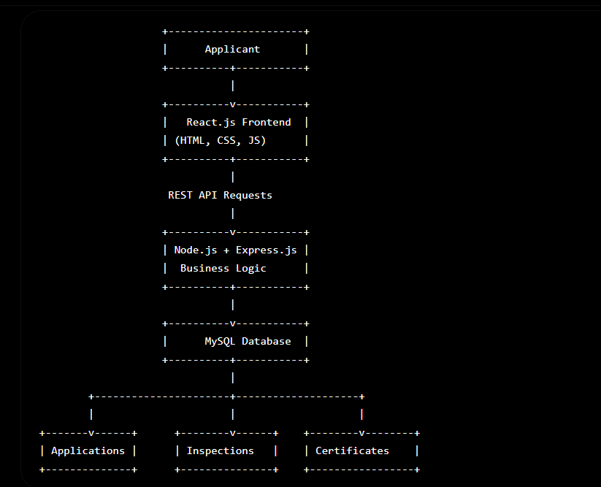

CHAPTER -5 DESIGN

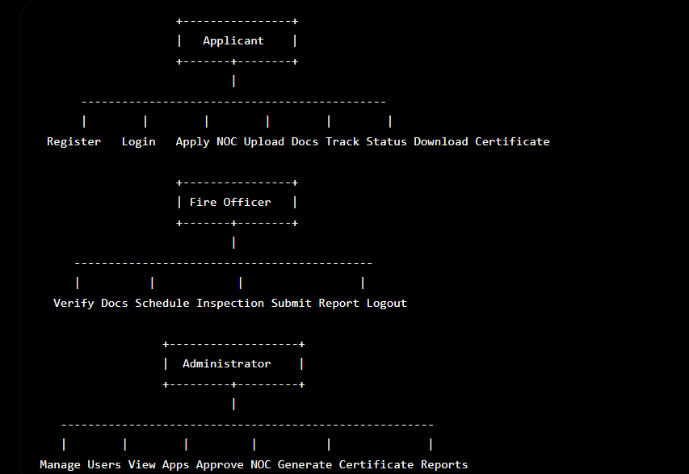

CHAPTER -6 IMPLEMENTATION

Section 6.1 – Module-Wise Implementation

Implementation is the phase in the Software Development Life Cycle (SDLC) where the system design is converted into a fully functional software application. In this phase, all the planned modules, database tables, APIs, user interfaces, and security mechanisms are developed and integrated to create the Fire NOC Application Portal.
The Fire NOC Application Portal is implemented using a modern full-stack web development approach. The frontend is developed using React.js, HTML5, CSS3, and JavaScript (ES6+), while the backend is implemented using Node.js and Express.js. The application uses MySQL for data storage and RESTful APIs for communication between the client and server.
The implementation follows a modular architecture, making the system easier to understand, maintain, and enhance. Each module is independently developed and tested before integration into the complete application.

Section 6.2 – Front-End Logic (UI Rendering and State Management)

The frontend provides the graphical interface for applicants, fire officers, and administrators. It is implemented using React.js with reusable components.
Major Frontend Pages
- Home Page
- Login Page
- Registration Page
- Applicant Dashboard
- Fire NOC Application Form
- Upload Documents Page
- Inspection Status Page
- Certificate Download Page
- Admin Dashboard
- Reports Page
Each page is designed to provide a simple, responsive, and user-friendly experience.

Home Page
The Home Page is the first page users see when accessing the portal.
Features include:
- Navigation Bar
- About Fire NOC
- Services
- Benefits
- Login Button
- Register Button
- Contact Information
- Footer
Purpose:
- Introduce the portal.
- Provide easy navigation.
- Display important announcements.

Registration Module
The registration page allows new users to create an account.
Input Fields:
- Full Name
- Email Address
- Mobile Number
- Address
- Password
- Confirm Password
Validation includes:
- Required fields
- Valid email format
- Mobile number validation
- Password strength
- Matching passwords
After successful registration:
- User details are stored in MySQL.
- Password is encrypted using bcrypt.
- Confirmation message is displayed.

Login Module
The login page authenticates users.
Input:
- Email
- Password
Process:
- User enters credentials.
- Backend verifies details.
- JWT Token is generated.
- Dashboard opens.
Benefits:
- Secure authentication
- Session management
- Role-based access

Applicant Dashboard
After login, applicants are redirected to their dashboard.
Dashboard Features:
- Welcome Message
- New Fire NOC Application
- My Applications
- Track Status
- Notifications
- Download Certificate
- Profile
- Logout
The dashboard provides quick access to all portal services.

Fire NOC Application Form
This is the core module of the portal.
The applicant enters:
Applicant Information
- Name
- Mobile Number
- Email
- Address
Building Information
- Building Name
- Building Type
- Building Address
- Number of Floors
- Total Area
- Occupancy Type
Fire Safety Details
- Fire Extinguishers
- Alarm System
- Emergency Exits
- Sprinkler System
- Water Tank Capacity
The applicant submits the form after verifying the details.

Document Upload Module
Applicants upload required documents.
Documents include:
- Building Plan
- Fire Safety Plan
- Structural Stability Certificate
- Ownership Certificate
- Identity Proof
- Address Proof
Validation:
- PDF/JPG/PNG only
- Maximum file size limit
- Duplicate file prevention
The uploaded files are stored securely and linked to the application record.

Application Tracking Module
Applicants can track the status of their Fire NOC application.
Possible statuses:
- Submitted
- Under Verification
- Inspection Scheduled
- Inspection Completed
- Approved
- Rejected
This feature provides transparency and reduces the need for office visits.

Certificate Download Module
After approval, applicants can:
- View Certificate
- Download PDF
- Print Certificate
Certificate contains:
- Certificate Number
- Applicant Name
- Building Address
- Issue Date
- Expiry Date
- Digital Signature
- QR Code (Future Enhancement)

CHAPTER 7- FEATURES

The Fire NOC Application Portal is a web-based e-Governance system developed to automate the complete Fire No Objection Certificate (Fire NOC) application process. The portal provides a centralized platform where applicants can submit applications, upload documents, schedule inspections, track application status, and download approved certificates online.
Unlike the traditional manual system, the proposed portal minimizes paperwork, reduces processing time, increases transparency, and improves communication between citizens and the Fire Department. It is designed to be secure, scalable, user-friendly, and accessible from any device with an internet connection.
The portal consists of several functional modules, each responsible for a specific task. These modules work together to ensure smooth processing of Fire NOC applications from registration to certificate issuance.

7.2 Functional Features
The Fire NOC Application Portal provides the following major functional features.
1. User Registration
New users can create an account by providing their basic details.
Registration information includes:
- Full Name
- Email Address
- Mobile Number
- Residential Address
- Password
Benefits
- Secure account creation
- Unique user identification
- Easy access to services

2. Secure Login
Registered users can log in using their credentials.
Authentication includes:
- Email Verification
- Password Validation
- JWT Authentication
- Session Management
Advantages
- Secure access
- Unauthorized access prevention
- User-specific dashboard

3. Fire NOC Application Submission
Applicants can submit Fire NOC applications completely online.
The application form includes:
Applicant Details
- Name
- Contact Information
- Address
Building Details
- Building Name
- Building Address
- Building Type
- Number of Floors
- Total Area
Fire Safety Details
- Fire Extinguishers
- Smoke Detectors
- Alarm Systems
- Emergency Exits
- Sprinkler System
Advantages
- Paperless application process
- Easy data entry
- Improved accuracy

4. Document Upload
Applicants can upload all required documents through the portal.
Supported documents include:
- Building Plan
- Fire Safety Layout
- Structural Stability Certificate
- Ownership Proof
- Identity Proof
- Address Proof
Supported formats:
- PDF
- JPG
- JPEG
- PNG
Benefits
- Secure document storage
- Easy verification
- Reduced paperwork

5. Application Status Tracking
Applicants can monitor the status of their applications in real time.
Application stages include:
- Submitted
- Under Verification
- Inspection Scheduled
- Inspection Completed
- Under Review
- Approved
- Rejected
Benefits
- Complete transparency
- Real-time updates
- Reduced office visits

6. Inspection Scheduling
Fire Department officers can schedule inspections through the portal.
Inspection information includes:
- Inspection Date
- Inspection Time
- Assigned Officer
- Building Location
Applicants receive notifications immediately after scheduling.

7. Inspection Report Management
After inspection, officers submit reports online.
Inspection reports contain:
- Building Condition
- Fire Equipment Verification
- Emergency Exit Status
- Safety Compliance
- Recommendations
Recommendations include:
- Approved
- Rejected
- Re-inspection Required

8. Certificate Generation
After successful verification and approval, the system automatically generates the Fire NOC certificate.
Certificate contains:
- Certificate Number
- Applicant Name
- Building Details
- Issue Date
- Validity Period
- Fire Department Seal
- Digital Signature
Applicants can download the certificate in PDF format.

9. Notification System
The system automatically sends notifications regarding:
- Registration
- Application Submission
- Document Verification
- Inspection Schedule
- Inspection Completion
- Approval
- Rejection
- Certificate Availability
Notification methods:
- Email
- SMS
- Dashboard Alerts

10. Report Generation
Administrators can generate reports such as:
- Daily Applications
- Monthly Applications
- Approved Applications
- Rejected Applications
- Pending Applications
- Inspection Reports
These reports help monitor departmental performance.

7.3 Applicant Features
The Applicant Module provides the following facilities:
- User Registration
- Secure Login
- Profile Management
- Online Fire NOC Application
- Building Information Submission
- Document Upload
- Application Tracking
- Notification Viewing
- Certificate Download
- Logout
Advantages
- User-friendly interface
- Faster application process
- Complete transparency

CHAPTER -8 TESTING

Postman Testing (Frontend/Backend)

Postman is one of the most widely used API testing tools for validating RESTful web services. In the Fire NOC Application Portal, Postman was used to test all backend APIs before integrating them with the React frontend. It helped verify that each API endpoint functioned correctly, returned appropriate HTTP status codes, and handled invalid requests gracefully.

During development, the frontend (React.js) communicated with the backend (Node.js and Express.js) through REST APIs. Postman was used to independently test these APIs, ensuring that backend functionality was reliable before frontend integration.

Objectives of Postman Testing
- Verify all REST API endpoints.
- Validate request and response data.
- Test authentication using JWT tokens.
- Check database connectivity.
- Verify CRUD (Create, Read, Update, Delete) operations.
- Test error handling.
- Ensure secure API communication.
Advantages of Postman Testing
- Fast API validation
- Easy debugging
- Supports authentication testing
- Tests request and response formats
- Supports automated testing
- Reduces integration errors

Integration Testing

Integration Testing verifies that all modules of the Fire NOC Application Portal work together correctly after individual testing. It ensures smooth communication between the frontend, backend, and database.
The purpose of integration testing is to identify defects that may occur due to interaction between different modules.

Modules Integrated
The following modules were integrated and tested:
- Registration Module
- Login Module
- Applicant Dashboard
- Fire NOC Application Module
- Document Upload Module
- Database Module
- Inspection Module
- Notification Module
- Certificate Generation Module

Tools Used for Testing

Description of Testing Tools
1. Postman
Used for:
- API Testing
- JWT Authentication
- Response Validation
- CRUD Testing

2. Google Chrome
Used for:
- UI Testing
- Responsive Design Testing
- Browser Compatibility
- JavaScript Execution

3. React Developer Tools
Used for:
- Component Inspection
- State Monitoring
- Props Verification
- Performance Analysis

4. MySQL Workbench
Used for:
- Database Verification
- SQL Query Execution
- Data Validation
- Table Management

5. Browser Developer Tools
Used for:
- Network Requests
- Console Logs
- CSS Inspection
- JavaScript Debugging

Advantages of Using These Tools
- Faster debugging
- Better code quality
- Accurate API validation
- Improved database testing
- Enhanced frontend performance
- Reduced development time

Test Cases and Results

The Fire NOC Application Portal was thoroughly tested using Postman, browser developer tools, MySQL Workbench, and React Developer Tools. All major functionalities, including user registration, authentication, application submission, document upload, inspection scheduling, certificate generation, and administrative operations, performed as expected. The integration between the React frontend, Node.js backend, and MySQL database was successful, and all critical test cases passed without major defects. The testing process confirmed that the system is reliable, secure, user-friendly, and ready for deployment.

CHAPTER -9 DEPLOYMENT

Steps to Deploy

Deployment is the final phase of the Software Development Life Cycle (SDLC), where the completed application is made available for users to access over the internet or an organization's internal network. After successful development and testing, the Fire NOC Application Portal is deployed to a production environment so that applicants, fire officers, and administrators can use the system in real-time.
The deployment process involves preparing the application, configuring the server, setting up the database, deploying both frontend and backend components, and verifying that all modules function correctly in the production environment.
The Fire NOC Application Portal follows a modern deployment architecture in which the React.js frontend, Node.js/Express.js backend, and MySQL database are hosted separately to improve scalability, performance, and maintainability.

Step 1: Prepare the Application
Before deployment, ensure that:
- All project modules are completed.
- Source code is error-free.
- Testing is successfully completed.
- All APIs are working correctly.
- Database tables are created.
- Required dependencies are installed.

Environment Configuration

Environment configuration refers to setting up all software, tools, and services required for the application to run successfully in the deployment environment.

Proper configuration ensures that the application behaves consistently across development, testing, and production environments.

Software Requirements
Component | Version
Operating System | Windows 10/11 or Ubuntu Linux
Node.js | Version 18 or above
npm | Latest Version
React.js | Latest Stable Version
Express.js | Latest Stable Version
MySQL | Version 8.0
Git | Latest Version
Visual Studio Code | Latest Version
Google Chrome | Latest Version

Hardware Requirements
Hardware | Specification
Processor | Intel Core i3 or above
RAM | Minimum 8 GB
Hard Disk | 100 GB Free Space
Internet | Broadband Connection

Backend Configuration

Install backend dependencies.

npm install

Configure:

Database connection

JWT Secret

Email service

File upload directory

CORS policy

Frontend Configuration

Configure API base URL.

Example:

const API_URL = "https://api.firenocportal.com/api";

Configure:

React Environment Variables

API endpoints

Authentication

Build configuration

Database Configuration

Create MySQL user.

Grant privileges.

Example:

GRANT ALL PRIVILEGES
ON fire_noc_db.*
TO 'fireadmin'@'localhost';

Flush privileges.

FLUSH PRIVILEGES;

Security Configuration

Configure:

HTTPS

SSL Certificate

JWT Authentication

Password Encryption

Firewall Rules

Database Backup

Access Control

These configurations ensure secure deployment.

Hosting of Frontend and Backend

The Fire NOC Application Portal follows a separate hosting strategy for the frontend and backend, allowing each component to scale independently.

Frontend Hosting
The frontend is developed using React.js and deployed as static files.
Suitable hosting platforms include:
- Netlify
- Vercel
- GitHub Pages
- Firebase Hosting
Deployment process:
- Build the React project.
- Upload the build folder.
- Configure the domain.
- Connect the backend API.
- Test all pages.
Advantages
- Fast content delivery
- Automatic deployment
- Global CDN support

- Free SSL certificates
- Easy scaling

Backend Hosting
The backend is developed using Node.js and Express.js.
Suitable hosting platforms include:
- Render
- Railway
- AWS EC2
- Microsoft Azure
- Google Cloud Platform
- DigitalOcean
Deployment steps:
- Upload backend source code.
- Install dependencies.
- Configure environment variables.
- Connect MySQL database.
- Start the Node.js server.
- Test API endpoints.
Advantages
- High availability
- Better scalability
- Secure API hosting
- Automatic restart on failure
- Easy maintenance

Database Hosting
The MySQL database can be hosted on:
- Local Server
- AWS RDS
- Azure Database for MySQL
- Google Cloud SQL
Benefits include:
- Automated backups
- High reliability
- Data security
- Disaster recovery
- High performance

CHAPTER -10 CHALLENGES & LIMITATIONS

Issues Faced During Development

During the development of the Fire NOC Application Portal, several technical and implementation challenges were encountered. These challenges arose while integrating the frontend, backend, database, authentication mechanisms, file upload functionality, and deployment environment. Each issue required careful analysis and appropriate solutions to ensure that the application remained secure, reliable, and user-friendly.
Although the project successfully meets its primary objectives, certain limitations and known issues still exist. These limitations can be addressed in future versions through additional enhancements, improved infrastructure, and integration with advanced technologies.

The development of the Fire NOC Application Portal involved overcoming several practical challenges.
1. Frontend and Backend Integration
Challenge
Initially, the React.js frontend was unable to communicate with the Node.js backend because of incorrect API URLs and Cross-Origin Resource Sharing (CORS) restrictions.
Impact
- API requests failed.
- Login functionality did not work.
- Application submission was unsuccessful.
- Data could not be retrieved from the server.

2. Database Connectivity Issues
Challenge
Connecting the Node.js backend with the MySQL database required proper configuration of database credentials and connection settings.
Problems Encountered
- Incorrect database credentials
- Connection timeout
- SQL syntax errors
- Database connection failures

3. User Authentication
Challenge
Implementing secure user authentication using JWT (JSON Web Token) required proper token generation, validation, and expiration handling.
Difficulties
- Invalid token generation
- Unauthorized access
- Session expiration
- Protected route implementation

4. Password Security
Challenge
Storing passwords in plain text was insecure.
The challenge was implementing secure password encryption.

5. File Upload Management
Challenge
Applicants upload important documents such as building plans and ownership certificates.
Problems included:
- Unsupported file formats
- Large file sizes
- Duplicate uploads
- Incorrect file paths

6. Form Validation
Challenge
Many users attempted to submit incomplete or invalid forms.
Examples:
- Empty required fields
- Invalid email format
- Incorrect phone numbers
- Missing building details

7. API Error Handling
Challenge
Initially, APIs returned generic server errors that made debugging difficult.
Problems included:
- Internal Server Error (500)
- Bad Request (400)
- Unauthorized (401)
- Not Found (404)

8. Responsive User Interface
Challenge
Some pages displayed correctly on desktop devices but had layout issues on mobile phones and tablets.
Problems included:
- Misaligned forms
- Overflowing tables
- Small buttons
- Improper navigation menus

9. Inspection Workflow Management
Challenge
Synchronizing the inspection scheduling process between applicants and fire officers required careful handling of application status updates.
Issues included:
- Duplicate inspection schedules
- Incorrect status changes
- Missing notifications

10. Certificate Generation
Challenge
Automatically generating Fire NOC certificates in PDF format while ensuring correct applicant details and formatting.
Problems included:
- Incorrect certificate data
- PDF formatting issues
- Download failures

11. Git Version Control Conflicts
Challenge
When multiple developers worked on different modules, merge conflicts occasionally occurred.
Examples:
- Conflicting code changes
- Deleted files
- Duplicate components
- Version mismatch

12. Deployment Configuration
Challenge
Deploying the frontend and backend separately required proper configuration of environment variables, API endpoints, and database connections.
Common issues included:
- Missing environment variables
- Incorrect API URLs
- Database connection errors
- Deployment failures

Solutions Applied

To overcome the above challenges, several practical solutions were implemented.

Solution for Frontend and Backend Communication
- Configured CORS middleware in Express.js.
- Verified API endpoints.
- Updated frontend API URLs.
- Tested APIs using Postman.
Result:
Frontend and backend communicated successfully.

Solution for Database Connectivity
- Verified MySQL configuration.
- Corrected database credentials.
- Used connection pooling.
- Tested SQL queries before implementation.
Result:
Stable and reliable database communication.

Solution for Authentication
JWT authentication was implemented.
Process:
- Generate token after login.
- Store token securely.
- Validate token for every protected request.
- Handle expired tokens appropriately.
Result:
Secure user authentication and authorization.

Solution for Password Security
Passwords were encrypted using bcrypt before storing them in the database.
Benefits:
- Improved security.
- Protection against password theft.
- Secure login verification.

Solution for File Upload
The Multer middleware was implemented.
Features:
- File type validation.
- File size restriction.
- Unique file names.
- Secure storage location.
Result:
Reliable document upload process.

Solution for Form Validation
Validation was implemented on both the frontend and backend.
Checks included:
- Required fields
- Email format
- Phone number validation
- Password strength
- File validation
Result:
Reduced invalid data submissions.

Solution for Error Handling
A centralized error-handling middleware was implemented.
Meaningful messages were displayed such as:
- Invalid Credentials
- File Upload Failed
- Database Error
- Unauthorized Access
- Application Not Found
Result:
Improved debugging and better user experience.

Solution for Responsive Design
Responsive design techniques were applied using:
- CSS Flexbox
- CSS Grid
- Media Queries
- Bootstrap Components (where applicable)
Result:
Application works properly on desktop, tablet, and mobile devices.

Solution for Inspection Workflow
Workflow automation was implemented.
Features:
- Automatic status updates.
- Notification system.
- Inspection scheduling validation.
- Duplicate prevention.
Result:
Smooth inspection management.

Solution for Certificate Generation
A PDF generation library was integrated into the backend.
The generated certificate includes:
- Certificate Number
- Applicant Details
- Building Information
- Approval Date
- Digital Signature
- Official Seal
Result:
Successful PDF generation and download.

Solution for Git Conflicts
The following practices were adopted:
- Feature branches
- Pull requests
- Code reviews
- Frequent commits
- Regular synchronization with the main branch
Result:
Reduced merge conflicts.

Solution for Deployment
Deployment issues were resolved by:
- Creating environment configuration files.
- Updating API URLs.
- Configuring production databases.
- Testing deployment after every update.
Result:
Successful deployment of both frontend and backend.

Current Limitations or Known Bugs

Although the Fire NOC Application Portal functions successfully, some limitations remain.

1. Internet Dependency
The application requires a stable internet connection.
Without internet access, users cannot:
- Register
- Login
- Submit applications
- Download certificates

2. No Offline Support
Currently, the portal does not support offline operations.
Future versions may include:
- Offline data synchronization
- Progressive Web App (PWA) support

3. Limited Notification Methods
Currently, notifications are available through:
- Email
- Dashboard alerts
Future enhancements may include:
- WhatsApp notifications
- Mobile push notifications

4. No Mobile Application
The current system is web-based only.
Future enhancement:
- Android Application
- iOS Application

5. Limited Payment Integration
The current project does not include online payment functionality.
Future versions may integrate:
- UPI
- Credit/Debit Cards
- Net Banking
- Government Payment Gateway

6. No GIS-Based Building Mapping
The application currently stores only textual building addresses.
Future enhancement:
- Google Maps integration
- GIS location tracking
- Building coordinates

7. QR Code Verification
The current certificate contains standard details only.
Future enhancement:
- QR Code verification
- Instant certificate authentication

8. AI-Based Risk Assessment
Currently, inspections are performed manually.
Future versions may include:
- AI-based fire risk prediction
- Automatic safety recommendations
- Predictive analytics

9. Scalability Constraints
The current implementation is suitable for small and medium-scale deployments.
For nationwide deployment, additional infrastructure would be required, including:
- Load balancing
- Distributed databases
- Cloud auto-scaling
- Microservices architecture

10. Minor Known Bugs
Some minor issues identified during testing include:
- Slow file uploads on low-bandwidth networks.
- Session timeout after long periods of inactivity.
- Large PDF documents may take longer to process.
- Browser cache may occasionally display outdated information until refreshed.
These issues do not affect the core functionality of the system and can be resolved through future updates.
nt principles.

CHAPTER -11 FUTURE ENHANCEMENTS

Planned Features

The Fire NOC Application Portal has been developed to digitize and simplify the process of applying for a Fire No Objection Certificate (Fire NOC). The current system successfully provides essential services such as online registration, application submission, document upload, inspection scheduling, application tracking, and certificate generation.
Although the system fulfills the primary requirements, continuous technological advancements and evolving user needs create opportunities for further improvements. Future enhancements can make the portal more intelligent, secure, scalable, and user-friendly. These enhancements will improve operational efficiency, enhance public service delivery, and support smart governance initiatives.
The following planned features are proposed for future versions of the Fire NOC Application Portal.

Advantages of Future Enhancements

The proposed enhancements will provide several benefits:
- Improved user experience
- Faster processing of applications
- Enhanced security and authentication
- Better transparency
- Increased automation
- Reduced paperwork
- Improved scalability
- Better inter-department coordination
- Efficient inspection management
- Smart governance support
- Higher citizen satisfaction
- Cloud-based reliability
- Support for future technological advancements

Possible Integrations or Optimisations

To further improve the efficiency, security, and scalability of the Fire NOC Application Portal, several integrations and optimizations can be implemented in future versions. These enhancements will enable seamless communication with other government systems, improve application performance, automate manual processes, and provide a better experience for both applicants and Fire Department officials.
The following integrations and optimizations are proposed to make the system more robust and suitable for large-scale deployment.

Advantages of Integrations and Optimisations
The proposed integrations and optimizations provide the following benefits:
- Improved application performance
- Enhanced security and reliability

- Faster processing of Fire NOC applications
- Better interoperability with government systems
- Reduced manual effort through automation
- Real-time notifications and communication
- Secure online payment processing
- Efficient document management
- Advanced analytics for administrators
- Increased scalability for future growth
- Improved citizen satisfaction
- Support for smart e-Governance initiatives

CHAPTER -12 CONCLUSION

  - Summary of the Project

The Fire NOC Application Portal was developed as a comprehensive web-based e-Governance solution to simplify and digitize the process of obtaining a Fire No Objection Certificate (Fire NOC). Traditionally, the Fire NOC approval process involved manual paperwork, multiple office visits, lengthy verification procedures, and delays in certificate issuance. The proposed system addresses these challenges by providing an online platform that enables applicants to complete the entire process efficiently and transparently.

The portal was developed using modern web technologies, including React.js for the frontend, Node.js and Express.js for the backend, and MySQL for database management. The application follows a three-tier architecture that separates the presentation layer, business logic layer, and database layer, ensuring better maintainability, scalability, and security.

The project includes several important modules such as user registration, secure login, Fire NOC application submission, document upload, application status tracking, inspection scheduling, inspection report management, certificate generation, and administrative management. Secure authentication using JWT, password encryption using bcrypt, and proper input validation have been implemented to protect user information and maintain data integrity.
Extensive testing was performed using tools such as Postman, browser developer tools, and MySQL Workbench to verify that all functionalities worked correctly. The application was also designed to support future enhancements such as AI-based fire risk assessment, QR code verification, online payments, GIS integration, and cloud deployment.

Overall, the Fire NOC Application Portal provides a reliable, secure, user-friendly, and scalable solution that improves the efficiency of Fire Department operations while offering better services to citizens.

What Was Achieved

The successful development of the Fire NOC Application Portal resulted in the achievement of the following project objectives:
1. Digitalization of the Fire NOC Process
The manual application process was successfully transformed into a fully digital system, reducing paperwork and simplifying the overall workflow.

2. Online User Registration and Authentication
Applicants can securely register and log in to the portal using authenticated user accounts protected through JWT authentication and encrypted passwords.

3. Online Fire NOC Application Submission
Applicants can complete and submit Fire NOC applications online without visiting government offices.

4. Secure Document Upload
The portal enables applicants to upload all required documents in supported formats, allowing easy verification by Fire Department officials.

5. Application Status Tracking
Users can monitor the progress of their applications in real time, improving transparency and reducing uncertainty.

6. Inspection Management
Fire officers can schedule inspections, record inspection reports, and update application statuses through the portal.

7. Automated Certificate Generation
Upon successful approval, the system automatically generates Fire NOC certificates that can be downloaded by applicants.

8. Administrative Control
Administrators can efficiently manage users, applications, inspections, certificates, and reports through a centralized dashboard.

9. Improved Security
Security mechanisms such as JWT authentication, bcrypt password hashing, role-based access control, and input validation were implemented to protect sensitive information.

10. Improved Transparency and Efficiency
The online system significantly reduces processing time, minimizes manual errors, improves communication, and enhances transparency throughout the Fire NOC approval process.

Major Achievements
The project successfully achieved the following:
- Developed a complete full-stack web application.
- Implemented secure user authentication and authorization.
- Created RESTful APIs for communication between frontend and backend.
- Designed and implemented a relational MySQL database.
- Enabled secure document upload and storage.
- Automated inspection scheduling and certificate generation.
- Successfully integrated frontend, backend, and database modules.
- Performed comprehensive testing to ensure system reliability.
- Designed a responsive and user-friendly interface.
- Proposed future enhancements for scalability and smart governance.

Skills Learned During Development

The development of the Fire NOC Application Portal provided valuable technical, analytical, and professional learning experiences. The project enhanced knowledge in full-stack web development, database management, software engineering practices, testing, deployment, and teamwork.
Technical Skills
During the project, the following technical skills were developed:
Frontend Development
- HTML5
- CSS3
- JavaScript (ES6+)
- React.js
- Responsive Web Design
- Component-Based Development

Backend Development
- Node.js
- Express.js
- REST API Development
- Middleware Implementation
- Server Configuration

Database Management
- MySQL
- SQL Queries
- Database Design
- Table Relationships
- CRUD Operations
- Data Normalization

Authentication and Security
- JWT Authentication
- Password Hashing using bcrypt
- Role-Based Access Control
- Input Validation
- Error Handling
- Secure API Development

Testing Skills
Experience was gained in:
- API Testing using Postman
- Frontend Testing
- Integration Testing
- Database Testing
- User Acceptance Testing
- Debugging and Error Resolution

Version Control
Knowledge gained in:
- Git
- GitHub
- Repository Management
- Branching
- Code Collaboration
- Version Tracking

Deployment Skills
Practical experience was obtained in:
- Environment Configuration
- Application Deployment
- Backend Hosting
- Frontend Hosting
- Database Configuration
- Production Build Management

Software Engineering Skills
The project strengthened understanding of:
- Software Development Life Cycle (SDLC)
- Requirement Analysis
- System Design
- UML Diagrams
- Modular Programming
- Documentation
- Software Testing
- Project Deployment

Problem-Solving Skills
Throughout the project, several challenges were encountered and resolved, leading to improvements in:
- Logical thinking
- Debugging techniques
- Error analysis
- Performance optimization
- Decision-making
- Analytical reasoning

Communication and Professional Skills
The project also contributed to the development of professional skills such as:
- Technical documentation
- Project planning
- Time management
- Team collaboration
- Presentation skills
- Report writing

CHAPTER -13 REFERENCES

Books

Pressman, R. S., & Maxim, B. R. (2019). Software Engineering: A Practitioner’s Approach (8th ed.). McGraw-Hill Education.

Freeman, E., & Freeman, E. (2020). Head First HTML and CSS (2nd ed.). O’Reilly Media. Duckett, J. (2014). HTML & CSS: Design and Build Websites. Wiley.
Duckett, J. (2015). JavaScript and JQuery: Interactive Front-End Web Development. Wiley. Sommerville, I. (2016). Software Engineering (10th ed.). Pearson Education.

Tutorials and Learning Resources

W3Schools. (2025). HTML, CSS, and JavaScript Tutorials. Retrieved from https://www.w3schools.com

MDN Web Docs. (2025). Web Technologies Documentation. Retrieved from https://developer.mozilla.org

FreeCodeCamp. (2025). Responsive Web Design Certification. Retrieved from https://www.freecodecamp.org

GeeksforGeeks. (2025). Front-end Development and Web Technologies. Retrieved from https://www.geeksforgeeks.org

Tutorialspoint. (2025). HTML, CSS, JavaScript, and Web Development Tutorials. Retrieved from https://www.tutorialspoint.com

APIs and Tools Used

Google Maps Platform. (2025). Maps JavaScript API Documentation. Retrieved from https://developers.google.com/maps

Unsplash API. (2025). Free High-Resolution Image Access. Retrieved from https://unsplash.com/developers

OpenWeatherMap. (2025). Weather API for Travel Assistance. Retrieved from https://openweathermap.org/api

RapidAPI Hub. (2025). Travel and Tourism APIs. Retrieved from https://rapidapi.com/hub

Firebase by Google. (2025). Authentication and Database Services. Retrieved from https://firebase.google.com

Documentation and Research References

World Tourism Organization (UNWTO). (2024). Tourism Data Dashboard. Retrieved from https://www.unwto.org

Booking.com. (2025). Accommodation and Destination Insights. Retrieved from https://www.booking.com

TripAdvisor. (2025). Tourism and Destination Review Data. Retrieved from https://www.tripadvisor.com

Travel + Leisure. (2025). Top Global Destinations and Travel Trends. Retrieved from https://www.travelandleisure.com

Tourism Review. (2025). Digital Transformation in the Tourism Industry. Retrieved from https://www.tourism-review.com

CHAPTER -14 APPENDICES

Screenshots of the app

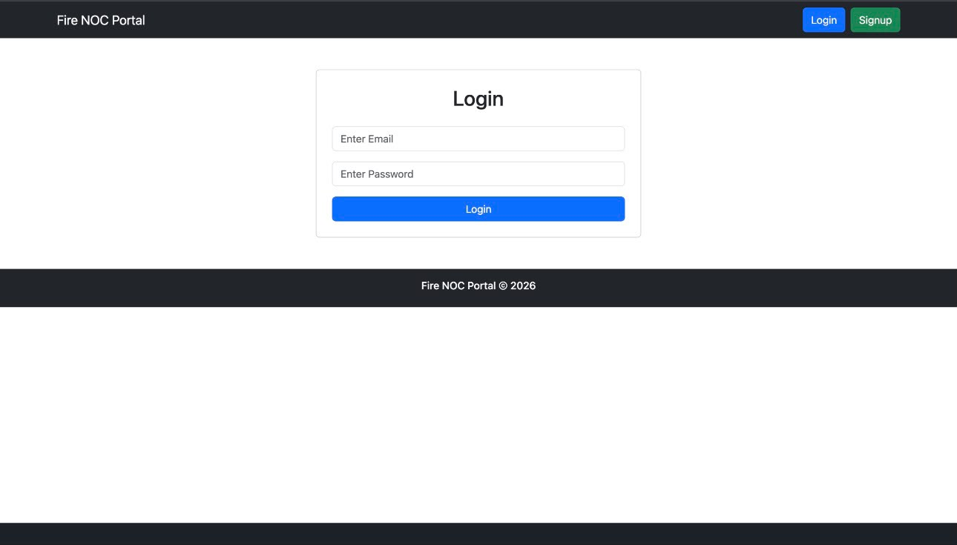

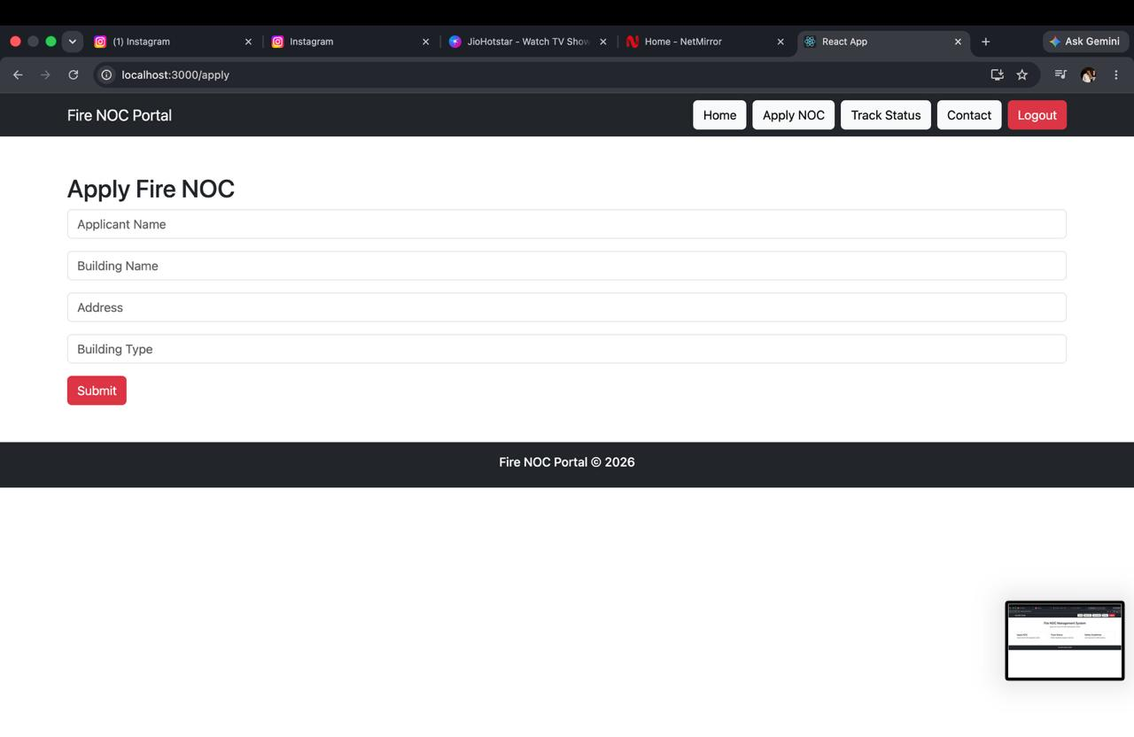

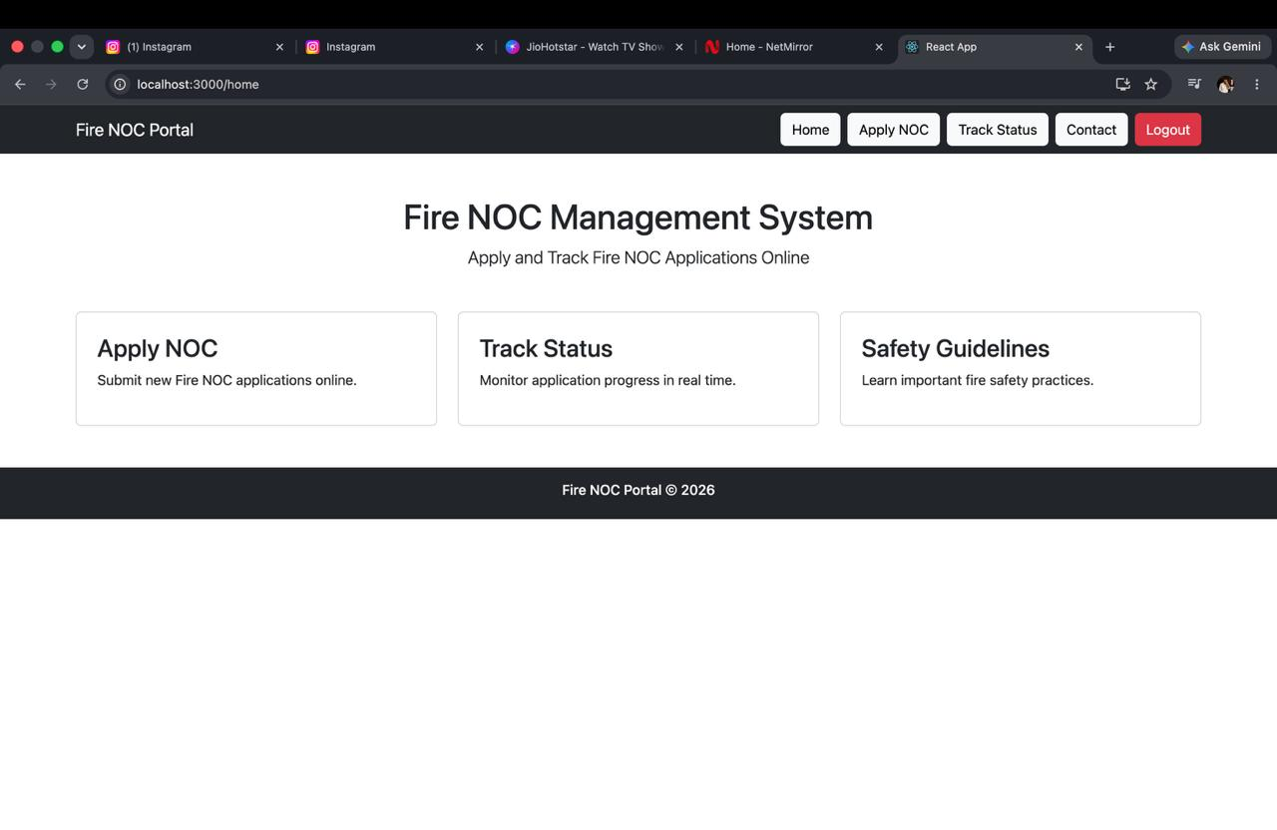

Sample code snippets

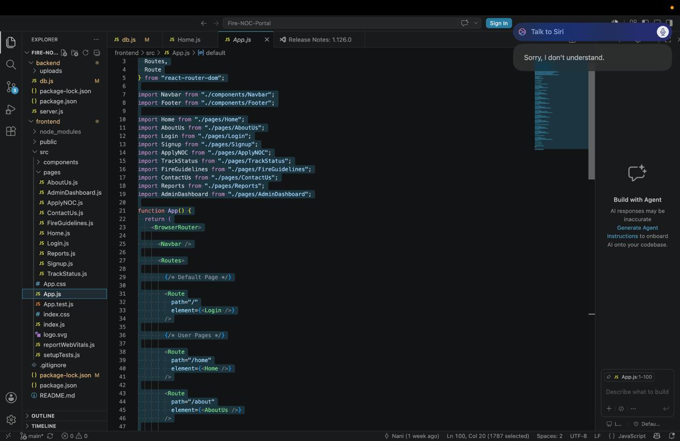

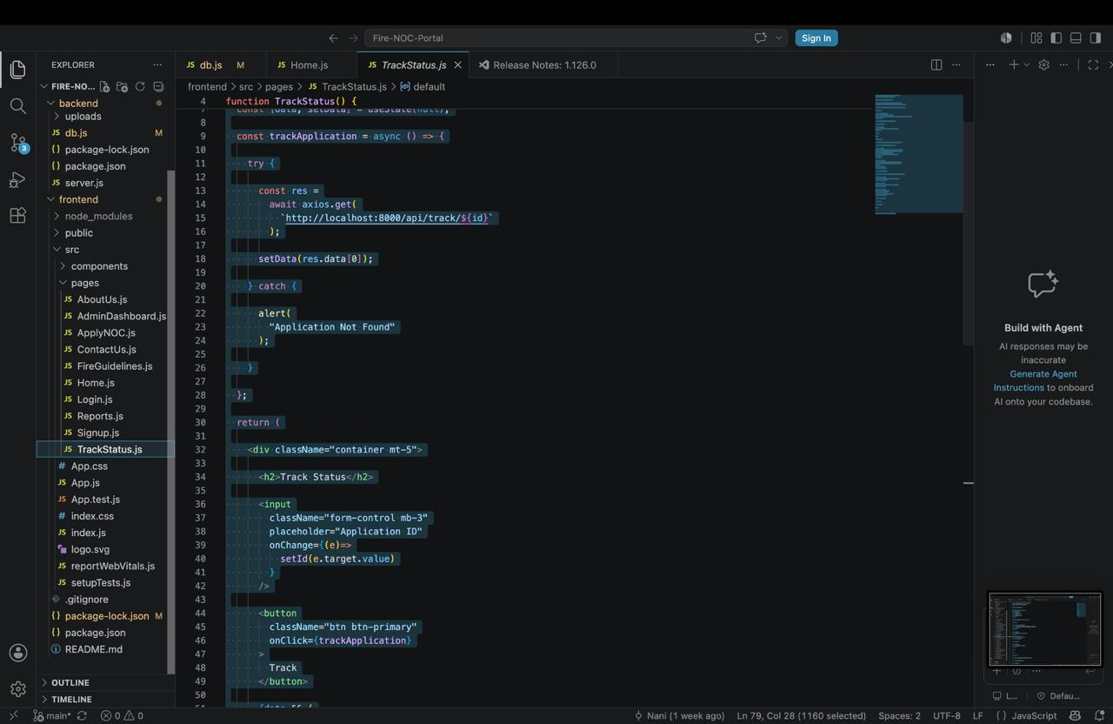
Geo-tag Photos



